- Before Start Formatting the paper, set the page layout for Whole document. Set the paper type for the whole document.
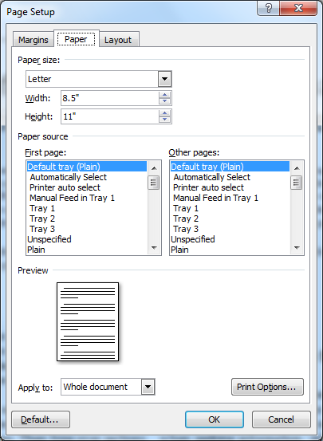

- Set the Paper Margines for the whole document.
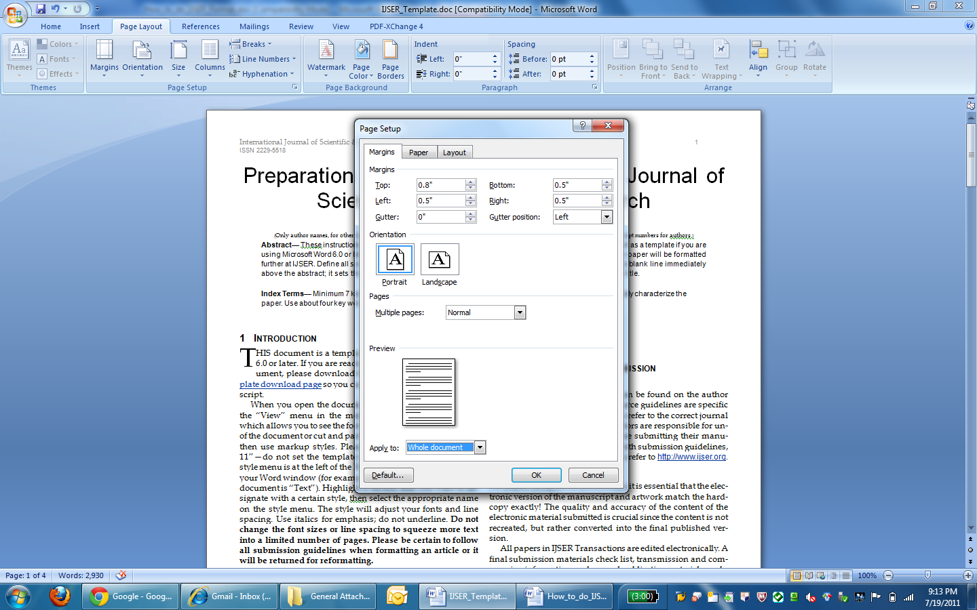

- Set Header/ Footer for the whole document.
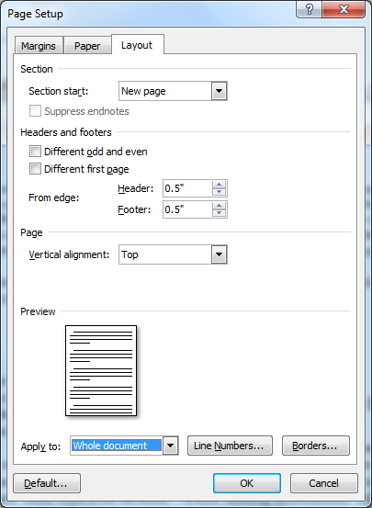

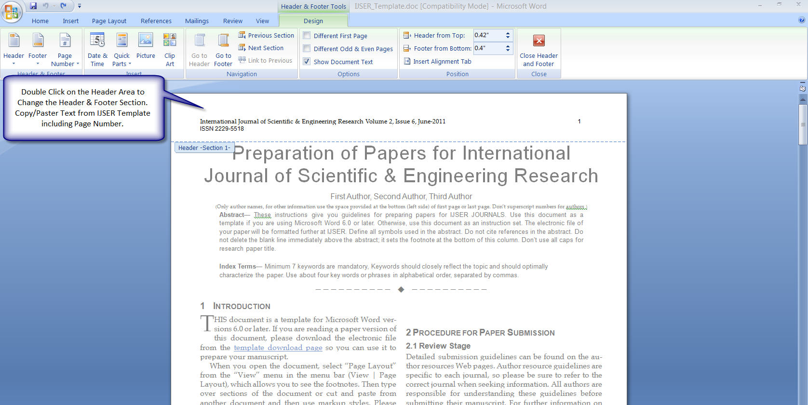

Then go to your Research Paper and then select the Header Area Text to Re-format it.
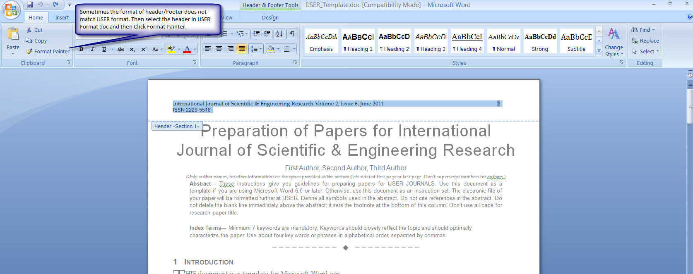

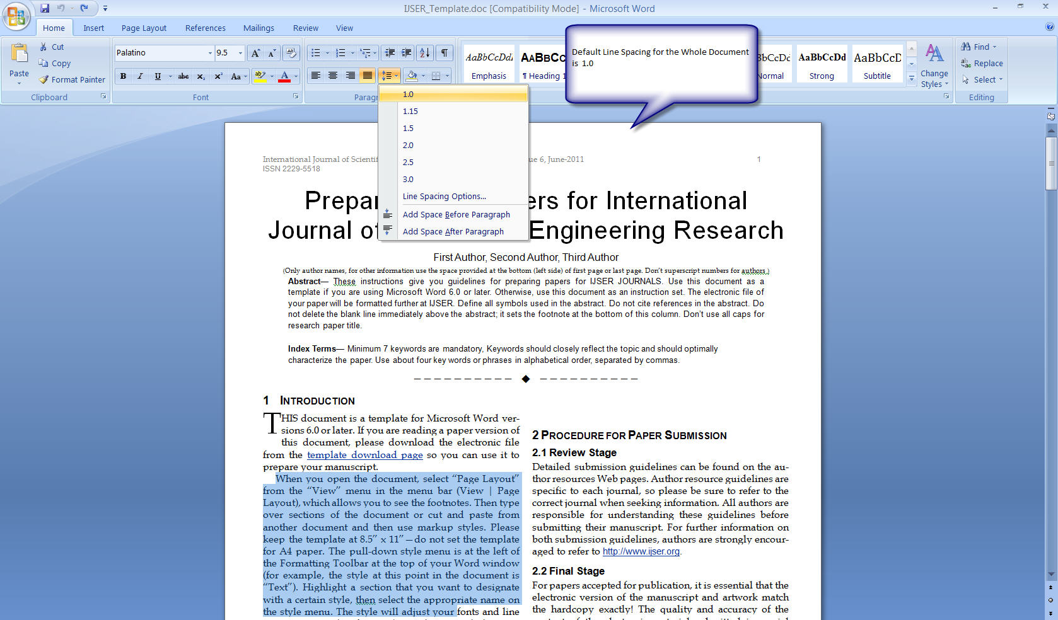

How To Set Font Style

Always Use Format Painter to Set the Font Style.

- Select the text in IJSER format template document.
- Click Format Painter. ( The cursor will change to brush type. )
- Then goto Your document select the text you want to format.

Manually Use can set the Font Style as stated below:

Title - Helvetica / 24
Author Names- Helvetica / 9.5
Abstract/Keywords/Index Terms Title - Helvetica / 8 / Bold
Abstract/Keyword/Index Terms Contents - Helvetica / 8

Main Paper Content - Palatino / 9.5

How To Set Two Column Format

Select the text which you want to set in two column.
Go to PageLayout - > Columns-> Select two column.

Note:- Simple way is to use format painter to format the font style of anything in document.

Before submitting paper for final publication.

- Do not capitalize all the letters of Paper Title / Author names.

- Below title only author names are allowed, do not subscript numbers, email or any other detail.

- Author details can be provided left side bottom of first page as specified in the format. Or you can provide details about authors in the last page.

- Font style/size of the paper should be according to IJSER format.

- Page Margins, paper type settings should be according to IJSER format.

- File name should start with PaperID_Paper Title, words should be connected by symbol (_) underscore. Any special character should be removed from the file name. Only alphabets, numbers and _ (underscore) is allowed.

- Set the document properties as shown below.

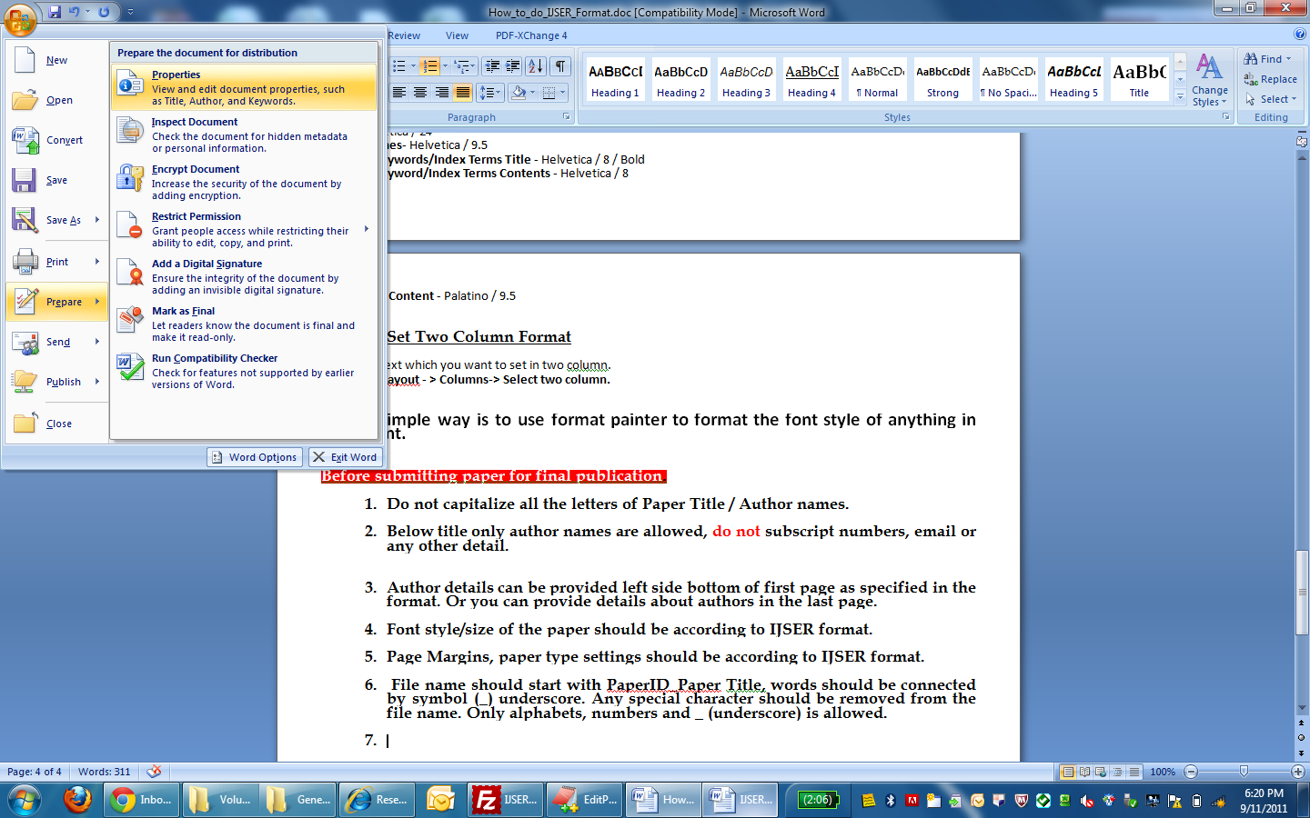
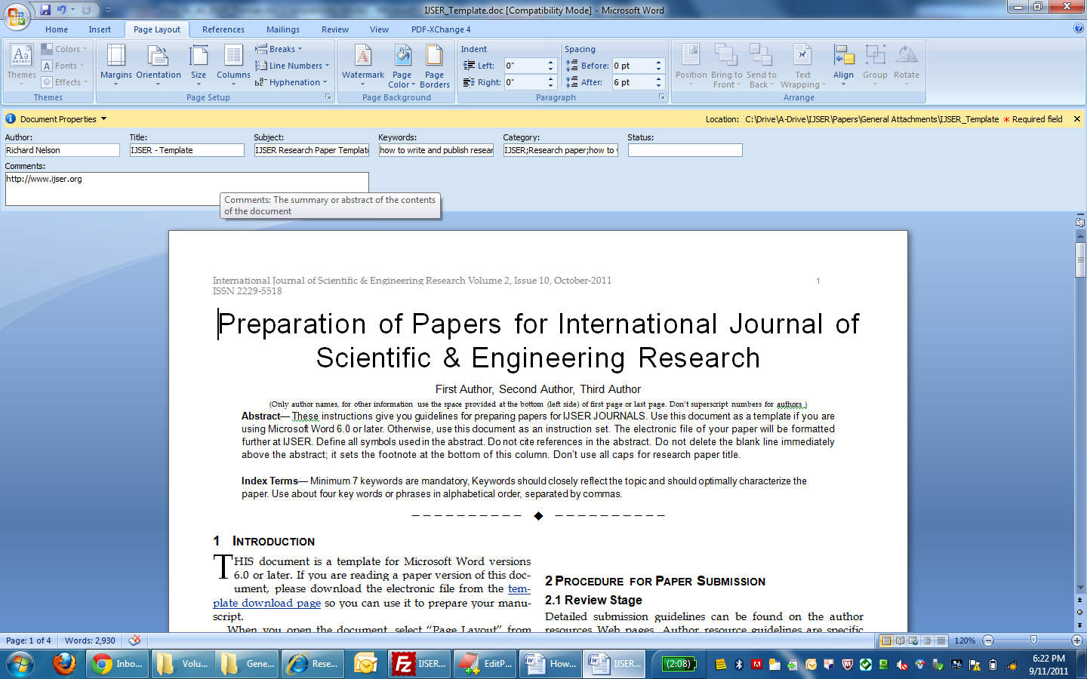
Click Properties then the following window will appear. Then set author name, Paper title, Subject ( IJSER Volume , Issue, edition ), Keywords, Category ( Set “IJSER Research paper), Status (http://www.ijser.org) and in Comments ( copy & paste Abstract of paper)

